STRUCTURAL AND MICROSTRUCTURAL CHARACTERIZATION OF U3SI2 NUCLEAR FUEL USING X-RAY DIFFRACTION

|  |
| --- |
| **Rodrigo U. Ichikawa1, Rafael H. L. Garcia1, Andre S. B. da Silva1, Xavier Turrillas2, Adonis M. Saliba-Silva1, Nelson B. Lima1 and Luis G. Martinez1**  1 Instituto de Pesquisas Energéticas e Nucleares (IPEN / CNEN - SP)  Av. Professor Lineu Prestes 2242  05508-000 São Paulo, SP  [ichikawa@usp.br](mailto:ichikawa@usp.br), [rlgarcia@ipen.br](mailto:rlgarcia@ipen.br), [andre.santos.silva@usp.br](mailto:andre.santos.silva@usp.br), [saliba@ipen.br](mailto:saliba@ipen.br), [nblima@ipen.br](mailto:nblima@ipen.br), [lgallego@ipen.br](mailto:lgallego@ipen.br)  2 Institut de Ciència de Materials de Barcelona (ICMAB / CSIC)  Campus de la UAB 08193 Bellaterra  Cerdanyola de Vallès, España  [xturrillas@icmab.es](mailto:xturrillas@icmab.es) |

# ABSTRACT

In this work, two U3Si2 powdered samples were analyzed using X-ray diffraction, one obtained using 67% and 60% of Si. For structural characterization, Rietveld refinement was used to estimate cell parameters, volume fraction in weight percent and atomic positions. For the main phases, X-ray line profile analysis was used to estimate mean crystallite sizes and microstrains. The analysis provide important results to steer the material application as nuclear fuel.

# INTRODUCTION

Nuclear fuels based on uranium silicide compounds are used in mostly modern research reactors. Specifically, U3Si2 is used on the IPEN IEA-R1 nuclear reactor, with own production since 2004 [1]. U3Si2 is particularly interesting since has very interesting properties such as high density, high thermal conductivity at room temperature and high melting temperature [2]. Also, uranium silicide based nuclear fuels will be used in the new Brazilian Multipurpose Research Reactor (Reator Multipropósito Brasileiro - RMB, in portuguese), an open pool type materials testing reactor (MTR) [3], which aims Brazil’s autonomy in the radioisotopes production for nuclear medicine.

Since uranium silicide based fuels is a key material and a detailed structural and microstructural study is necessary. For instance, the control of crystalline phases when the material is processed is extremely important, since each phase have different behaviors under irradiation. In this sense, the correct phase identification and quantification is very important to match the correct specifications for its use in the nuclear area [4].

In this work, uranium silicide melts with different stoichiometries were produced and analyzed using X-ray diffraction based techniques. X-ray diffraction provides a non-destructive type of analysis considering a large volume fraction of the sample. Rietveld analysis was performed to determine the weight percent of each phase present in the material. Also, cell parameters and atomic positions were also obtained. For the microstructural analysis, Warren-Averbach method was used to estimate mean crystallite size and microstrain for the main phase.

# EXPERIMENTAL

# The samples were synthesized…

The X-ray diffraction data was collected…

# 3. METHODS

## 2.1. Rietveld analysis

Rietveld analysis minimizes the difference between the experimental data and the model using a least squares procedure. The background was modeled using a Chebychev sixth-order polynomial and the profile with the modified Thompson-Cox-Hastings (TCHz) function. Cell parameters, non-special atomic positions and volume fraction (weight percent) were refined. Also, volume weighted mean crystallite size (${〈L〉}_{V}$) and microstrain was estimated for the main phase. The refinements were performed using the software *TOPAS 4.2* [5].

**2.1. X-ray line profile analysis**

X-ray line profile analysis (XLPA) was performed using Warren-Averbach method through a software developed by the authors [6]. Warren-Averbach method is the most unbiased method to determine mean crystallite size and microstrains since there is no fit to the experimental data. The Fourier Transform is performed in two peaks that must correspond to parallel reflections, this permits the calculation of the area weighted mean crystallite size (${〈L〉}_{A}$) and the root mean square strain (RMSS) from the Fourier coefficients. A detailed description on how the method can be applied and the definitions used can be found elsewhere [6].

# 3. RESULTS AND DISCUSSION

First, phase identification was performed using Crystallographica Search-Match. USi2 (ICSD No. 31643) and U1.07Si2.14 (ICSD No. 76751) was identified for the 67Si sample. U3Si2 (ICSD No. 31648), USi (ICSD No. 31647) and USi1.0147 (ICSD No. 81561) was identified for the 42Si. Information about the crystal structure of each phase can be seen in Table 1. The reflections of each phase can be seen in Figures 1 and 2.

Table 1 – Information about the crystalline structure of each phase identified through search-match.

|  |  |  |  |  |  |
| --- | --- | --- | --- | --- | --- |
| **Sample** | **Phase** | **ICSD No.** | **Symmetry** | **Space group** | **No.** |
| **67Si** | **USi2** | **31643** | tetragonal | $$I41/amdS$$ | 141 |
| **U1.07Si2.14** | **76751** | cubic | $$Pm\overline{3}m$$ | 221 |
| **42Si** | **U3Si2** | **31648** | tetragonal | $$P4/mbm$$ | 127 |
| **USi** | **31647** | orthorrombic | $$Pbnm$$ | 62 |
| **USi** | **81561** | tetragonal | $$I4/mmm$$ | 139 |

Rietveld analysis was than performed using the CIF files mentioned above as starting models for the refinements. Highly crystalline CeO2 was used to obtain the instrumental profile function to perform mean crystallite size and microstrain calculations.

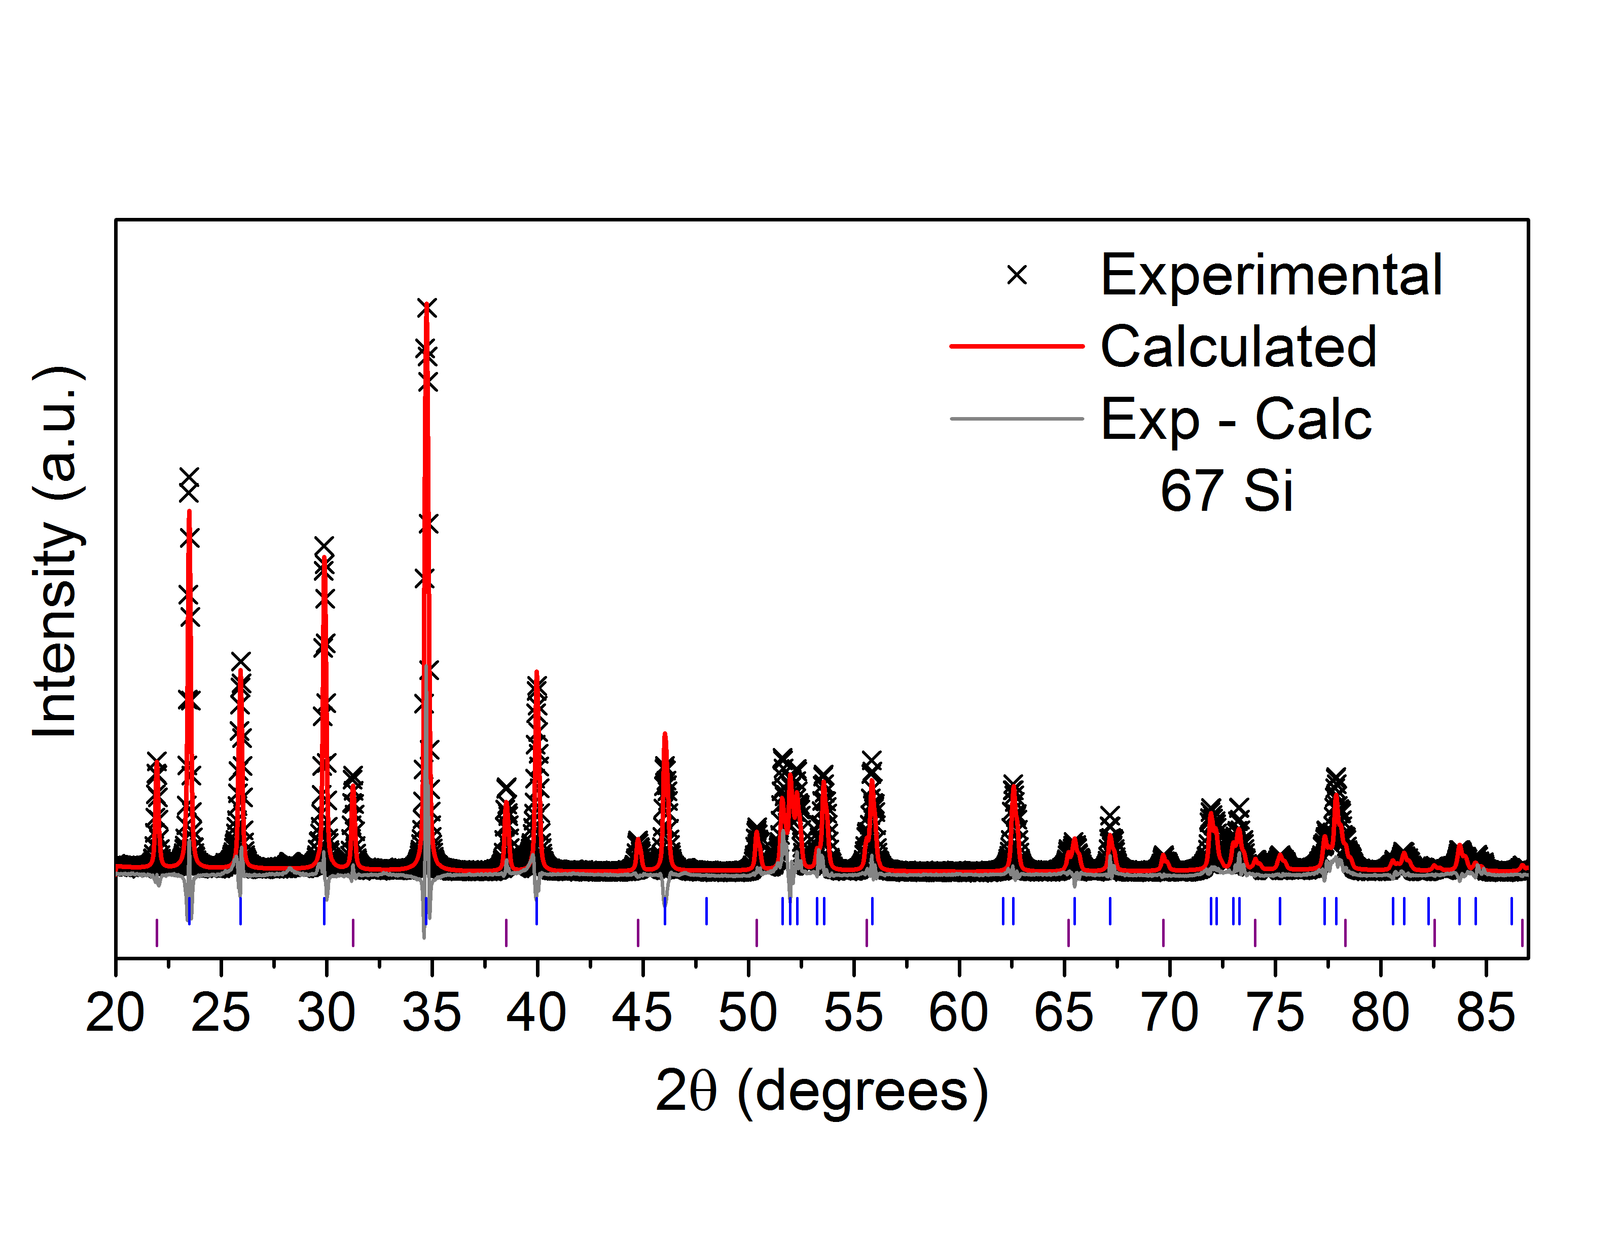

**Figure 1** – Rietveld refinement for the sample 67Si. The lines below the profiles stands for the reflections of USi2 (blue) and U1.07Si2.14 (purple).

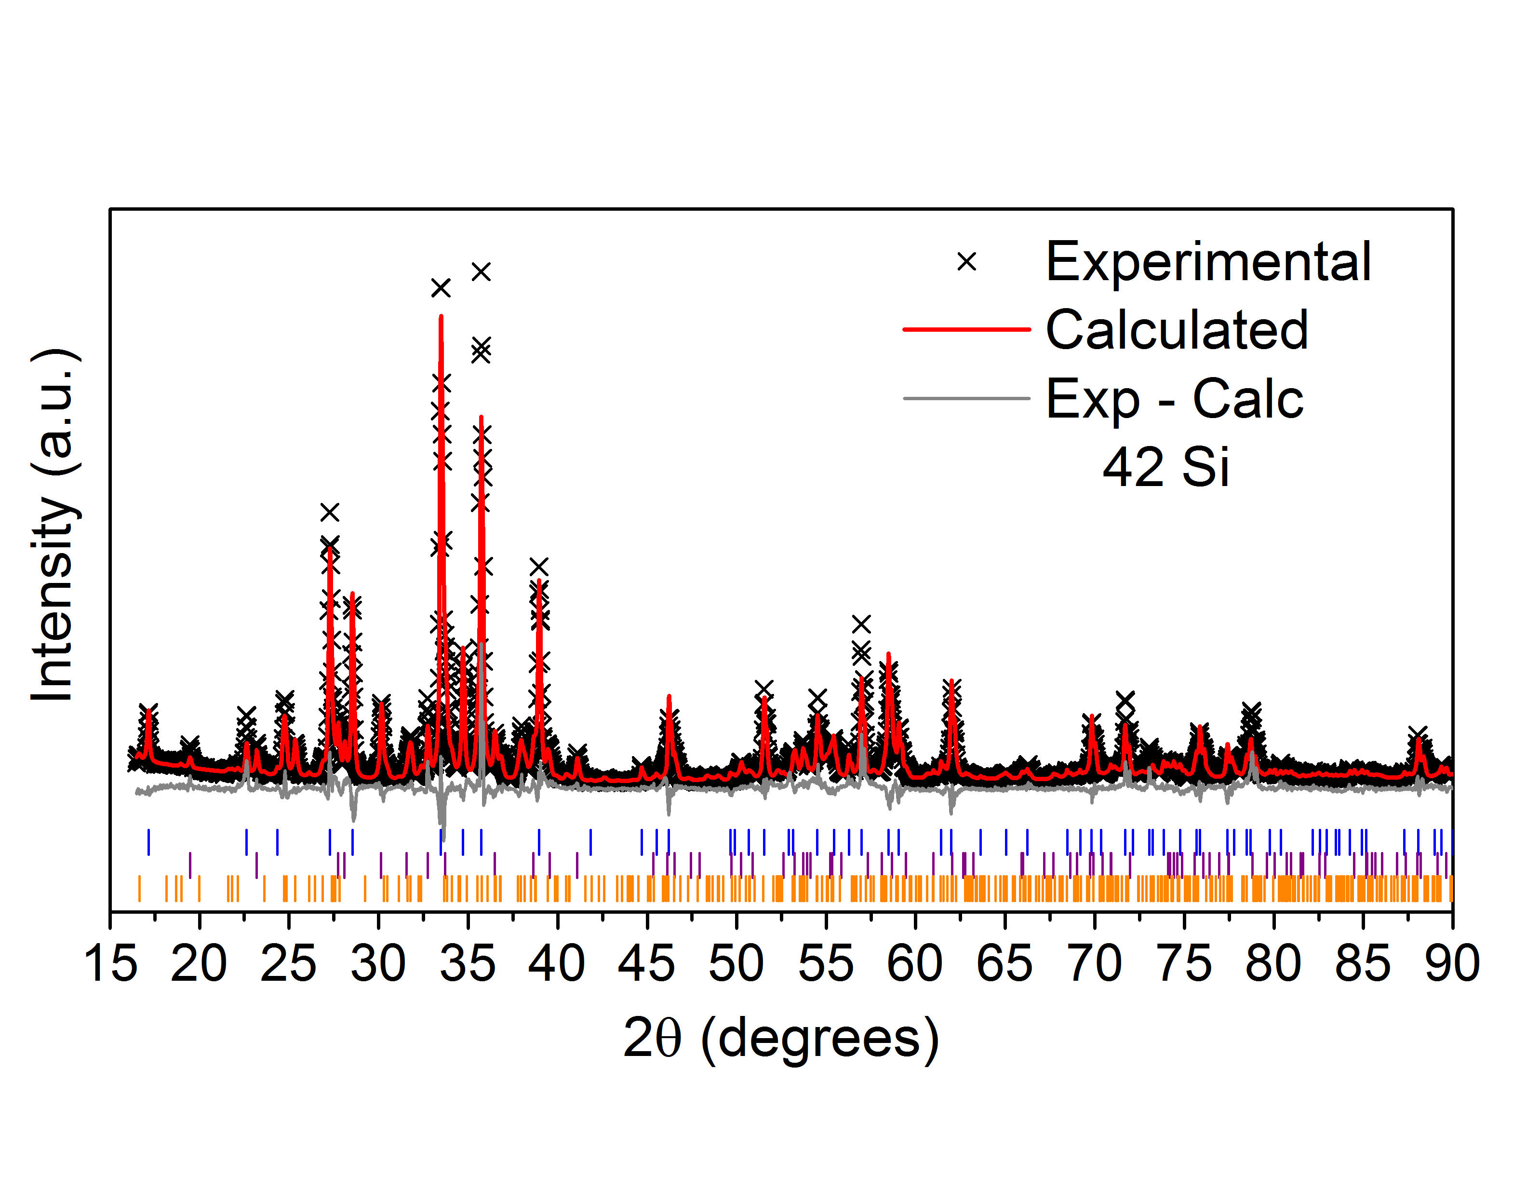

Figure 2 – Rietveld refinement for the sample 42Si. The lines below the profiles stands for the reflections of U3Si2 (blue), USi (purple) and USi1.0147 (orange).

An agreement factor (Rwp) of 18.9% and 15.7% was achieved for 67Si and 42Si, respectively. Scale factor, 6 background coefficients for the Chebyshev polynomial, cell parameters and atomic positions (for the main phase of each sample) were refined. Atomic displacement factors were kept fixed during the refinements.

The results were summarized in Table 2.

Table 2 – Results for the Rietveld refinement for samples 67Si and 42 Si.

|  |  |  |  |  |  |
| --- | --- | --- | --- | --- | --- |
| **Sample** | **67Si** | | **42Si** | | |
| **Phase** | **USi2**  **(# 31643)** | **U1.07Si2.14**  **(# 76751)** | **U3Si2**  **(# 31648)** | **USi**  **(# 31647)** | **USi**  **(# 81561)** |
| **a (Å)** | 3.9398(1) | 4.0460(1) | 7.3065(2) | 5.6636(80) | 10.6455(12) |
| **b (Å)** | 3.9398(1) | 4.0460(1) | 7.3065(2) | 7.6616(10) | 10.6455(12) |
| **c (Å)** | 13.7499(41) | 4.0460(1) | 3.9260(17) | 3.9008(53) | 24.4145(44) |
| **xU2** | - | - | 0.1802(3) | - | - |
| **xSi** | - | - | 0.3771(19) | - | - |
| **zSi** | 0.4217(14) | - | - | - | - |
| ${〈L〉}_{V}$**(nm)** | 64(2) | 67(6) | 73(5) | 56(7) | 40(4) |
| **e (10-5)** | 30(2) | 25(7) | 0* | 0* | 59(17) |
| **weight %** | 86.3(5) | 13.7(5) | 57.6(4) | 15.3(4) | 27.1(4) |

The Warren-Averbach method was used in the six samples, but in the orthorhombic sample, it cannot be applied due to the many overlapping of the peaks.

Table 3 – Results for the Warren-Averbach method for samples 67Si and 42 Si.

|  |  |  |  |  |  |
| --- | --- | --- | --- | --- | --- |
| **Sample** | **67Si** | | **42Si** | | |
| **Phase** | **U3Si2 31648 (tetragonal)** | **USi 31647 (orthorrombic)** | **USi 81561 (tetragonal)** | **U1.07Si2.14 076751 (cubic)** | **USi2 031643 (tetragonal)** |
| ${〈L〉}_{A}$**(nm)** | 29 | 22 | x | 23 | 28 |
| **RMSS (10-4)** | 1.9 | 2.7 | x | 7.2 | 7.4 |

The results of the profile analysis are within a good estimate.

# ACKNOWLEDGMENTS

RUI acknowledges CAPES and CNPq (No. 206983/2014-0) for financial support.

# REFERENCES

1. A. M. Saliba-Silva, M. Durazzo, E. F. U. de Carvalho and H. G. Riella, “Fabrication of U3Si2 Powder for Fuels Used in IEA-R1 Nuclear Research Reactor”, *Materials Science Forum*, **Vols. 591-593**, pp. 194-199 (2008).
2. K. E. Metzger, T. W. Knight, and R. L. Williamson. Model of U3Si2 fuel system using BISON fuel code. In Proceedings of the International Congress on Advances in Nuclear Power Plants - ICAPP 2014, Charlotte, NC, April 6–9 2014.
3. J. A. Perrotta, A. J. Soares, "RMB: The New Brazilian Multipropose Research Reactor",

International Journal for Nuclear Power, atw vol. 60 (2015), Issue 1, January.

1. J. L. Snelgrove, R. F. Doraagala, G. L. Hofraan and T. C. Wiencek, “The Use of U3Si2 Dispersed in Aluminum in Plate-Type Fuel Elements for Research and Test Reactors”. ANL/RERTR/TM-11. Argonne, IL (1987).
2. Bruker AXS, Topas v4.2, User’s manual (2009).
3. R. U. Ichikawa, L.G. Martinez, K. Imakuma, X. Turrillas, Development of a methodology for the application of the Warren-Averbach method, V Encontro Científico de Física Aplicada, Blucher Physics Proceedings, Volume 1, 2014, Pages 107-110, ISSN 2358-2359, <http://dx.doi.org/10.1016/phypro-ecfa-049>